**Abstract**

In structural and civil engineering, trusses are commonly used in many applications in order to realize the final vision of the desired structure. Trusses are inherently simple to construct, and they are extensively used across many disciplines to generate very complex systems. These disciplines include, but are not limited to: aerospace fuselages and wings, bridges, and skyscrapers. For these applications, the mass of the realized structures is a critical design parameter. Design optimization principles can be applied to minimize the mass and cost of the structure while maintaining sufficient strength and stiffness.

The main purpose of the proposed project is to minimize the cost and mass of the structure while ensuring sufficient load bearing characteristics. The configuration of the structure is assumed to be comprised of several equilateral triangles of fixed truss length. Since mass is directly proportional to the cross-sectional area of each truss, the objective function depends upon the area ***Ai*** of each truss element used in the structure. The mass and choice of material in turn affect the cost of the structure. A simplified schematic of the proposed structure can be seen in Figure 1 below.

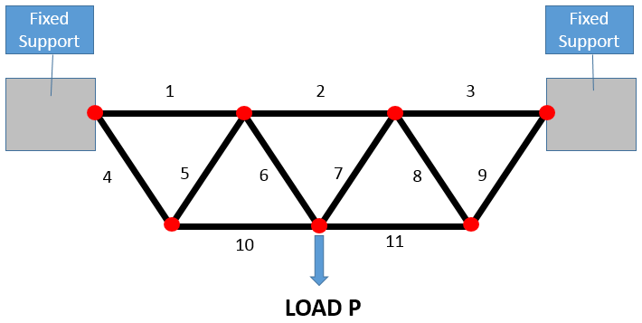

Figure 1: Schematic of truss structure with applied load P.

The proposed structure is comprised of 11 trusses. The mass for each individual truss must be found such that the mass of the entire structure is minimized. As seen in Figure 1, the structure is supported by two fixed supports, and each red node indicates a truss joint that is allowed to move in plane (***x***, ***y***) as a result of the load ***P***.

The design variables for this problem are the separate cross sectional areas ***Ai*** of each of the eleven truss elements. The cost function is the mass of the entire structure and is a function of the design variable ***Ai*** for ***i*** equal to 1 to 11 defined as **M(*Ai*)**. For minimizing cost, the simulation will be run for several materials of varying cost and stress parameters. The best choice will be selected.

The load ***P*** includes the weight of the trusses for a given material in addition to an external fixed weight that the bridge must support. The stress applied to each truss is constrained by the maximum yield stress $σ_{i}≤σ_{max}$ of the selected material. Three materials will be chosen for study. As an obvious constraint, it is implausible to have any ***Ai*** be negative. It is also infeasible to make trusses too large since the manufactured beam sizes for each material are limited. Therefore, ***A*** will be bounded by $A_{min}≤A≤A_{max}$ for each unique material.

The problem will be solved via the FEA method using truss element formulation. At this stage, it is unclear if the design problem will be coded in MATLAB or solved with a black box solver such as ABAQUS. The load ***P*** and size of the structure have not yet been determined, but will be selected in order to ensure that the solution is not obvious.